“Exploring the link between national- and club-level soccer performance:
A time-series analysis of FIFA rankings”∇

Narek Sahakyan*
University of Wisconsin-Madison

Michael W Nicholson**
U.S. Agency for International Development

David Kritzberg***
Appian Data Consultants, California

May 25, 2012

Despite the ubiquity of soccer fans and soccer talent throughout the global community, the highest quality of soccer on a weekly basis is played in European professional league and the last two World Cup championships have been decided by a match between European teams. The dominant national team of the current era, Spain, hosts a professional league with clubs experiencing nearly unprecedented international success. Is this a coincidence? At the time of its inception, Major League Soccer was intended as a domestic league for the United States to improve its national team performance following the 1994 World Cup. Has it worked? Do strong domestic leagues, or at least strong domestic clubs, improve national team success? Employing annual time-series data from 1993 onwards for all FIFA countries, this paper investigates potential links between a country’s soccer success at the club level and at the national level. By developing a “CLUB” indicator for domestic club strength and isolating its impact on national teams, we provide statistical evidence that a stronger domestic league positively affects national team performance.

JEL Classification: L83, H50

Introduction

More countries are members of the Fédération Internationale de Football Association (“FIFA”) than are members of the United Nations. Brands of football clubs such as Barcelona and Manchester United are sometimes more recognizable around the world than Coca-Cola. Despite the ubiquitous presence of soccer fans and soccer talent throughout the global community, the highest quality of soccer on a weekly basis is played in European professional leagues. The best non-European players generally play in their own domestic leagues if, frankly, they can’t make the cut in Europe. Exponentially higher salaries in European leagues, as well as other factors, such as corrupt and underdeveloped soccer institutions in their home countries, force the highest quality players from South America and Africa to relocate to Europe. International competition, however, is increasing, and despite an all-Europe final in the past two World Cups, countries outside the “core” have been improving their lot. In their influential book Soccernomics, Kuper and Szymanski (2009) question the conventional wisdom that England’s ‘recent’ slipping in national team success can be related to the increasing presence of foreign players in the English Premier League. Just a year after, the dominant national team of the 2010’s, Spain, overtook the number one ranking from the Brazilians following a superior performance at the World Cup in July of 2010, and have held on to the spot ever since. Concurrently, quite a few Spanish club teams have been enjoying unprecedented success with numerous titles and appearances in late stages of major European and international club tournaments. At the time of its inception in 1996, Major League Soccer was intended as a domestic league for the United States to improve its national team performance following the 1994 World Cup. Has it worked? Do strong domestic leagues, or at least strong domestic clubs, improve national team success? This paper investigates potential links between a country’s soccer success at the professional club level and at the national level.
The empirical literature on the determinants of cross-country football performance generally incorporates macroeconomic measures, geographic, human development measures, institutions, and other non-economic factors typical of international trade theory that may translate into long-term soccer success. In these studies, World Cup performance or FIFA points are usually regressed on a variety of wealth measures and population using a cross-section of countries. These variables are generally found to be good predictors of international soccer success, in which just population and income can explain upwards of 50% of variability in FIFA rankings. Common sense has dictated such controls as “LATIN” to help explain the success of countries like Uruguay and Argentina relative to the United States and China. In the top 20 list of FIFA rankings available since 1993, one can always consistently find relatively smaller and middle-income European and South-American countries, usually recognized by their strong soccer tradition. Other researchers have found that cultural, political or institutional factors, such as centrally planned economies or dictatorships to be associated with higher performance at the international stage. With a varying extent, all of these measures approximate how much a country cares about, or in other words, endows itself in soccer, either through its political regime diverting available resources to the development of soccer, or some inherent cultural or even religious disposition towards the sport. At the national level, a country’s soccer endowment shapes its team, comprised of the eleven on the field, the team coach, some substitutes and other staff. Under the constraint of national resources, the team is continually perfected and tested against other teams in international matches and competitions, outcomes of which determine the National Teams’ FIFA Points and thus, their relative rank.
We extend the existing literature in several ways. One major contribution of this paper is to model the relationship between soccer success and country-specific variables over time. To this end, we use FIFA Points available on FIFA’s website to construct an annual time series for all countries of in the world, spanning from 1993 to 2011. FIFA points are then regressed on national income measures (GDP per capita and a quadratic term) using World Bank’s World Development Indicators in a fixed-effects OLS model. To account for other country-specific factors, we then introduce additional dynamic policy- and resource- related variables and turn to analyzing the statistical relationships by confederation, to illustrate the varied effect of these variables in different parts of the world.
Following these baseline analyses, we construct an index “CLUB” (Country’s Club Rankings) as a proxy, for the nations’ soccer endowment, based on points accumulated annually by the country’s all club teams in club competitions. To make this club-level measure comparable to the national-level measure (FIFA), we only count club points earned in international club competitions. Due to the inherent endogeneity between these national- and club- level soccer performance measures (FIFA and CLUB), we use instrumental variables and two-stage least squares fixed-effects models for longitudinal data. Accounting for macroeconomic and resource variables, CLUB is found to have a statistically significant, but varying effect on national team performance.
Section 2 provides a brief literature review, focusing on the empirical studies on the determinants of international sporting performance. Section 3 presents the data and discusses identification. Section 4 develops the econometric specification and sets up the hypothesis tests. Section 5 provides results and Section 6 concludes.

Literature Review

It has been well established in the literature that large, rich countries generally perform better in international competitions, while also considering soccer-specific measures, such as history/tradition, policy and infrastructure, as well as non-economic geographic (or “gravity”) variables such as: distance from economic centers; colonial history; linguistic connections; and other attributes drawn from international trade theory. In a seminal work, Hoffman, Ging, and Ramasamy (2002) analyze the socioeconomic determinants of international soccer performance. Controlling for GDP, they find that teams from Europe and Latin America perform better at the World Cup than teams from other regions.
Houston and Wilson (2002) empirically evaluate the second-order effect of income on leisure proficiency, as measured by international soccer success. They regress countries’ FIFA points in year 2000 on per-capita-GDP and per-capita-GDP-squared, controlling for population, years enrolled in FIFA, World Cup appearances and Youth World Cup appearances. The results suggest that aggregate leisure (football) proficiency increases with income at a decreasing rate. Similarly, Macmillan and Smith (2007) control for playing experience, and find diminishing marginal returns to the impact of a country’s population on its success on the soccer field.
Foer’s (2004) book How Soccer Explains the World and subsequent June 2006 New Republic article “How governments nurture soccer” suggests three determinants: political regime, colonial heritage, and institutions. In his predictions, colonizers beat former colonies, oil producers are cursed, and domestic leagues are inconsequential for EU countries due to player transfers. Using 2006 cross-country data, Leeds and Leeds (2009) analyze these predictions by incorporating the following variables: Communist dummy, Freedom House Index, OECD dummy, colonial dummies, colonizer dummies, oil quantitative variable, and institutional proxies (host dummy, year dummy). Leeds and Leeds (2009) also include a plethora of dummy variables to estimate the effect of “soccer institutions” as measured by the country’s success and participation (number of club teams) in various international club championships. Contrary to two of Foer’s three “iron laws”, Leeds and Leeds (2009) find that oil producing countries do not underperform, and that having a strong domestic league helps performance at the national level.
History and culture clearly matter. Torgler (2004, 2008) investigates the determinants of national team success at the men’s and women’s FIFA World Cups (respectively). He uses the following variables: GDP per capita, Population, Temperature, Region, Tradition (Host, Men’s Ranking). Contrary to Houston and Wilson (2002), Torgler (2008) does not find the inverted-U relationship with GDP per capita with respect to women’s FIFA success.
Yamamura (2008) uses the soccer transfer market as a means of investigating the effect of linguistic heterogeneity on technology transfer and find that the learning effect is larger for developing countries than developed countries. They define ‘most developed countries’ – in terms of identifying the technology frontier – by the countries with the top four domestic leagues. Their variables include: technology level, years, World Cup appearances, GDP, pop, unemployment rate, language dummies, and ethno-linguistic fractionalization.
Luiz and Fadal (2010) find that sports performance in Africa depends on range of socioeconomic factors, and cite literature on: resource endowments, population, cultural & social resources, levels of urbanization; also, geophysical and climatic conditions.
Kavetsos and Szymanksi (2008) investigate the impact of international sports events, such as the Olympics, World Cup, and UEFA championship on national wellbeing. Following this focus on general national prosperity, we include elements of the Human Development Index as a measure of soccer capacity. Due to the lack of pre-2005 longitudinal data, we rely on per capita income and life expectancy at birth.
Baur and Lehmann (2007) question whether the cross-border mobility of soccer players influences the success of the national team with a focus on trade of players across borders. They find that both imports and exports help gains from trade. Their approach based in Ricardian comparative advantage, and they use both FIFA rankings and the market value of domestic clubs. They find that team success is determined by contributions of the worst-rated player on the team rather than the superstars. Their control variables include: age of players, footedness, and average number of games.
Another approach considers the transfer market, with mobility of labor as a predictive element of success. The dependent variable in this literature generally involves club performance, not national performance, and uses as a basis labor theory instead of trade or development theory.
Torgler (2008) analyzes the historical performance of countries in World Cup tournaments for the period of 1930 to 2002 and finds that popularity and tradition, as measured by membership in FIFA and having previously hosted a WC, have a big impact on World Cup success. He follows HGR by including temperature and population as predictors of WC success. Similar to Houston and Wilson (2002) he finds increasing, but diminishing marginal returns to income. Torgler (2007) re-introduces HGR’s LATIN variable, interacts it with population, and finds that this measure of “Latin-populated-ness” is a good predictor of football success. To make sure it is just the cultural component of the LATIN variable that is driving the statistical significance, Torgler then includes an income inequality measure (GINI), which is found to be insignificant, while “Latin-populated-ness” remains statistically significant.

Data

In analyzing the determinants of international soccer success, we have distinguished three types of variables: macroeconomic factors, natural resources, and soccer endowment (tradition). Table 1 summarizes the variables incorporated into our model with a note of expected signs based on relevant cites in the existing literature. We obtained all the non-soccer data from the World Development Indicators, for a set of 200 countries, spanning from 1993 to 2011. These variables are matched with annual FIFA points, which are available for this time period from the FIFA website and with Club rankings constructed from time-series data made available by Oosterpark Rankings. Coupled with evidence from previous studies on international sporting performance, an important factor in selecting the macroeconomic and resource variables used in the study was data availability. For example, while some other country-specific variables, such as per capita health expenditures, size of government revenues or unemployment rates may have proven to be informative proxies for national economic performance, poor data quality precludes us from including them as additional controls.

Table 1: Data summary
Variable | Abbreviation | Expected Positive Effect | Expected Negative Effect
Macroeconomic factors
GDP Per Capita | GDP | Hoffman, Ging, Ramasamy (2002)  Houston and Wilson (2002)  Torgler (2004, 208)  De Bosscher, et al. (2006)
GDP Per Capita Squared | GDP ² |  | Hoffman, Ging, Ramasamy (2002)  Houston and Wilson (2002)  Torgler (2007)
Trade as a percent of GDP | Trade | Milanovic (2004)  Baur and Lehmann (2007)
Inflation, consumer prices | Infl | - | -
Resources/Infrastructure/Demographic
Oil Rents as % of GDP | OilRents | Leeds and Leeds (2009)  Luiz and Fadal (2010) | Foer (2004, 2006)
Population | PopMil | Macmillan and Smith (2007)  Torgler (2007)
Population squared | PopMil ² |  | Macmillan and Smith (2007)
Life expectancy at birth | LFB | Kavetsos and Szymanksi (2008)
Urban population as % of total | UrbPop | Kuper and Szymanski (2009)
Endowment/Tradition
Host of World Cup | - | Torgler (2004, 2008)
Latin American culture | - | Hoffman, Ging, Ramasamy (2002)  Torgler (2007)
Domestic league quality / success | CLUB | Foer (2004)  Leeds and Leeds (2009)

Macroeconomic factors

GDP per capita. We expect this sign to be positive. All of the existing theoretic literature posits, and empirical literature finds a strong positive relationship between soccer success and national wealth measures. We include a quadratic term control for non-linear effects of wealth. Following Hoffman, Ging, Ramasamy (2002) and Houston and Wilson (2002), we expect a negative sign for the coefficient of the quadratic income term, pointing towards diminishing returns of income on football success.

Trade as a percentage of GDP. We use trade as a percentage of GDP as a measure exposure to global trading markets, as suggested by Milanovic (2004). This variable is often characterized in the trade literature as a proxy for “openness” , with an expected positive sign because more “open” countries have easier access to the best soccer know-how and talent, while more “closed” economies are isolated from the global community and are thus behind the learning curve.

Inflation. Inflation is included as a measure of national economic stability and health. While economic literature does not provide unequivocal evidence on adverse effects of high inflation on a country’s economy, shocks caused by national currency changes and sustained periods of high inflation are generally red flags for economic uncertainly and volatility.

Resources/Infrastructure/Demographic factors

Oil Rents as a percent of GDP. There is mixed evidence on the effect of oil resource utilization and national soccer performance. While Foer (2004, 2006) suggests that oil-producing countries should underperform, as "these countries lack a winning temperament and innovative mindset", Leeds and Leeds (2009) finds a positive effect, concluding that "either oil-rich countries provide much financial support for soccer, or oil-induced malaise [of being lazy] does not filter down to soccer performance." We do not hold a priori expectations regarding the sign of this coefficient.

Population. We expect a positive sign. A country’s population is a direct measure of the talent pool available. Countries that have access to a larger pool of talent should do better at producing high quality national teams. Similar to the national income variables, there is some evidence that higher population contributes to soccer success at a diminishing rate (Macmillan and Smith (2007)). To account for a non-liner relationship between population and soccer success, we include a quadratic term, which we expect to be negative.

Life Expectancy at Birth. We expect a positive sign. Healthier nations are expected to perform better.

Urban Population. Percent of urban population is the instrument we use to identify the simultaneous relationship between national- and club-level measures FPS and CLUB. Kuper and Szymanski (2009) provide an extensive discussion on the connections between large industrial towns and successful club teams. Since higher CLUB indicates lower quality club teams, and therefore lower soccer endowment, we except a negative and statistically significant coefficient (for proper identification).

3.3. Soccer tradition / Endowment

CLUB (Country’s Club Ranking). Stronger domestic club teams are a product of higher national soccer endowment and will correlate with higher performance at the international stage. Since higher CLUB indicates lower relative ranking in the world (as is with FIFA rankings), we expect a negative sign to reflect its inverse relationship with accumulated FIFA points.

We present some descriptive statistics in Tables A-1 and A-2 in the appendix, along with national- and club-level rankings for top and bottom FIFA and European countries. Presented figures are 19-year averages, spanning the period from 1993 to 2011. The countries are sorted by national strength, calculated by averaging annual FIFA rankings over the 19-year period. As a reference point, for each subgroup, maximum, mean and minimum figures for all the variables across the 19-year period are given in the top, middle and bottom rows of the tables.
Guided by the data summary provided in Table 1, in the top halves in Tables A-1 and A-2 we should look for countries with relatively higher club ranking (CLUB), per capita income (GDP) and population (PopMil). These countries should also be more “open” (Trade), have higher life expectancy (LFB) and lower inflation (Infl). Higher percent of urban population (UrbPop) should be accompanied with higher club rating (CLUB).
As the top half of Table A-1 clearly illustrates, throughout the last two decades European nations have dominated the international football stage. Out of top 15 FIFA counties, ten are European, three are South American and two are from North America. There is a strong connection between FIFA and Club Ranks evident from comparing the first two columns of Tables A-1 and A-2.
Furthermore, a side-by-side comparison of economic indicators of top soccer nations illustrates clear differences in the way countries utilize their resources to build teams. The undisputed leader over the last two decades, Brazil, has an average GDP per capita of $7,800, which is about three times lower than the subsequent three countries in the rankings. In fact, all three South American countries that are among the top 15, along with the two remaining non-Europeans - Mexico and Russia, have wealth measures just about equal to the average country in our sample. However, these countries compensate for this lack of wealth with their relatively large and urbanized populations, which respectfully contribute to national success directly through access to a larger talent pool and indirectly through higher soccer endowment, as reflected in their higher club-level rankings.
Income and population matter. However, to attribute international soccer success to only wealth and population would be naïve. Let’s compare, for example, two adjacent countries ranked 13 and 14 in Table A-1. Denmark and USA have very similar soccer achievements, both at the international and the club level. Danes and Americans live under very comparable (and comfortable) economic conditions – Americans get an extra $6,600 per year, both have experienced identical levels of inflation, and both Danish and American babies born between 1993-2011 can expect to live about 77 years. Even with an arguably “more closed” economy, it would seem that with a population size of about 53 times that of Denmark, the US should do a lot better than 14th in the world. As Soccernomics puts it, “If only Americans took soccer seriously, the country’s fabulous wealth and enormous population would translate into dominance.” Does that hypothetical path to dominance follow a stronger domestic league, or the inclusion of U.S. players in the top European leagues?

Econometric Specification

To seek the answer to whether dominance in international soccer requires a strong domestic league, we provide analysis for three separate estimating equations of increasing complexity. Equation 1 provides a baseline measure of the dynamic impacts of national wealth. This specification allows for an interpretation of the results of Ging, Ramasamy (2002) and Houston and Wilson (2002) over time:
- FIFA = f(GDP, GDP ²).
The second estimating equation expands on the basic wealth measures to include proxies for the other major determinants of international soccer success. This equation lends itself to a comparison of the determinants across the FIFA regions, to help identify why Europe and South America appear to be “special”:
- FIFA = f(GDP, GDP ², Trade, Infl, OilRents, PopMil, PopMil ², LFB).
The third estimating equation incorporates a measure of domestic league, CLUB (Country’s Club Strength), as a potential further determinant of FIFA ranking:
- FIFA = F(GDP, GDP ², Trade, Infl, OilRents, PopMil, PopMil ², LFB, CLUB).
Statistical estimation of (3), however, is complicated by an interesting relationship between FIFA and CLUB.
Figure 1 presents the Spearman correlation between FIFA and Club Rank, broken down by confederation. The strong positive correlation, particularly for the UEFA subgroup, as well as the evidence presented in Tables A-1 and A-2, suggest that soccer success at the national level goes hand in hand with stronger domestic clubs. Both FIFA and CLUB are determined by the outcomes of specific matches, and therefore, at the most basic level, the on-the-pitch performance of the players. The performance of the players, in its turn, depends on their inherent ability, plus some other unobservable factors, which may best be measured by their success at the most prestigious club competitions. The more players with a high-quality club/ league affiliation a country’s national team has, the more likely it will achieve success in international matches. This effect may be even stronger when the “high-quality” league/club coincides with that country’s own domestic league, such as in Spain, Germany, Italy, France and the Netherlands.
Figure 1: Spearman Correlation between FIFA rank and CLUB

For a given country, successful club teams and high quality leagues may “cause” high-quality national teams, directly due to a higher proportion of high-quality (local) players the managers can pick from, and indirectly due to the intensity of soccer competition in the country. It can be argued, however, that successful performance by players of a certain national team at a global stage like the World Cup will signal ability, and have an effect on the placement of high-ability players in successful and high-performing clubs of potentially any country, usually hosting a high-quality league. In the conditions of autarky (club teams recruit only local players) we would expect an almost perfect correlation between club success (CLUB) and national success (FIFA). In pure autarky, in which players performed only for their own nation’s domestic club teams, a country’s international club success would be a more refined version of national success, and we should be able obtain the latter if we aggregated the former: international competitiveness as the sum of domestic competitiveness. However, the cross-border trade of players introduces shocks in this relationship. For example, Leo Messi competes for a club team in Spain and at the national level for Argentina. While his contributions in international competition are directly to Argentina, there may exist indirect, “Messi effects” on the Spanish national team. On one hand, his presence elevates the quality of his Barcelona teammates Xavi and Iniesta as well as his capital city rivals Iker Casillas and Xabi Alonso, while all of them pull a joint effort under the Spanish national flag. On the other hand, if Spain were to face Argentina in an international match, Messi’s indirect contribution to Spain’s national team would arguably be offset by his direct contribution for La Albiceleste.
Many of the conditions that give rise to strong national teams, most notably wealth and population, may also lead to strong club teams. Due to this, equation (3) will suffer from identification as a statistical model, as CLUB is itself a function of the macro and resource variables. To compensate for this challenge we consider the element of country’s urban population.
Professional football clubs depend on attendance and a strong fan base for survival, which manifests itself in dense urban areas. Any relationship between urban population and national team success, as opposed to local club support, will be transmitted through the club success. If dense populations lead to stronger competitions or the development/discovery of particular talents, these players will emerge through club teams (even at a lower division); world-class soccer players do not simply emerge fully-formed on the international stage. Therefore, the identifying assumption for (3) is that country’s percent of urban population is not correlated with football success at the national level, (i.e. the higher FIFA rankings) through channels other than its effect on the country’s club strength. Post-estimation identification statistics (presented in Appendix A-3) confirm that the equation in exactly identified. The estimating equation therefore becomes:
  - FIFA = F(GDP, GDP², Trade%, Inflation, Life Exp, Oil Rents, Population, CLUB).
  - CLUB = F(GDP, GDPsq, Trade%, Inflation, Life Exp, Oil Rents, Population, Urban Population %).

Results

Equation (1)

Table 2 provides results for the full panel for equation (1) for 135 countries from 1993 to 2009 with estimates consistent with Hoffman, Ging, and Ramsey (2002) and Houston and Wilson (2002). The regressions suggest that a quadratic relationship appears to exist between GDP per capita and footballing success: countries tend to do better on the pitch as they get richer, up to a certain critical mass of wealth, after which the returns to GDP per capita are negative. Statistical tests suggest the presence of autocorrelation so the table includes results for an AR(1) correction without a major change in the results.

Table 2: Equation (1) by regional confederation
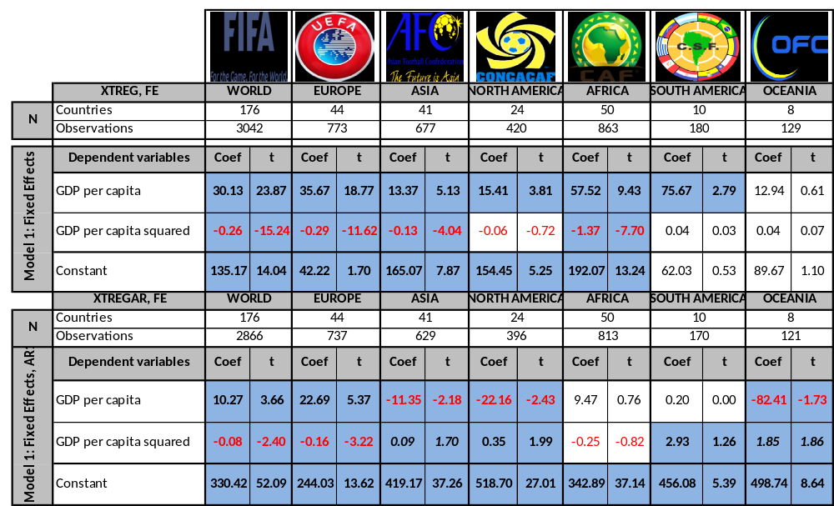

Using the pooled data, the “optimum” GDP per capita for success at international soccer is $10,671 (or about that of Argentina or Malta). Longitudinal country data allows for us to investigate changes over time, and Figure 2 illustrates dynamics of the optimal value. Note the large increase after 2006: since that year, the threshold for success has gotten higher; alternatively, this may suggest that since 2006, wealthier countries have performed better in international soccer competitions. In 2009, the optimal level was determined at $24,269, or about that of Belgium or Germany.
Figure 2: Optimal GDP in current international dollars

Equation (2)

Table 3 presents results of equation (2) using the full complement of explanatory variables regarding the determinants of FIFA success. Tests again strongly suggest autocorrelation, with corresponding results included in the table.
The additional economic and resource variables included in Equation 2 are generally of expected signs and are statistically significant for the whole dataset (FIFA) and for the majority of regions. Most importantly, the signs of coefficients of GDP and Population, along with their respective quadratic terms, are largely consistent with the findings from previous empirical studies. GDP has the biggest positive-diminishing effect in Africa, followed by Europe, while larger Population generates better soccer results in Europe, again followed by Africa. An exception to the “income and population rule” is South America, where higher per capita income and population seem to go with lower soccer success. In Asia, the coefficients on Population are also reversed (yet statistically insignificant) and likely driven by major soccer underachievers such as China and India.
Comparing the results from Equations 1 and 2 it is easy to observe that the magnitude and statistical significance of all variables gradually diminishes with escalading levels of equation complexity, particularly for Asian, African and North American countries. Notably, it is usually countries from the first two continents that, among other issues, suffer from serious data quality issues. North America, on the other hand is characterized by countries that generally “don’t follow the rules.” Americans and Canadians are major underachievers with respect to their GDP and population, while Mexicans are major overachievers with respect to their GDP.
The differences between the results of European and South American confederations tell an interesting story, at the heart of which is the balance between available resources and footballing tradition. Given the small number of available observations and countries in the South American sample (9 countries with 153 observations), as well as the extreme relative weight of the few nations within this subgroup, it is expected that the observed negative income effects are driven by the poor (in its economic meaning of the word) Brazil. Interestingly, the top three CONMEBOL countries are the ones that are least “open” in terms of Trade. Oil Rents also have an opposite effect on soccer success when comparing Europe to South America. It seems as though top European oil producers are suffering from a case of
Table 3: Results of equation (2)
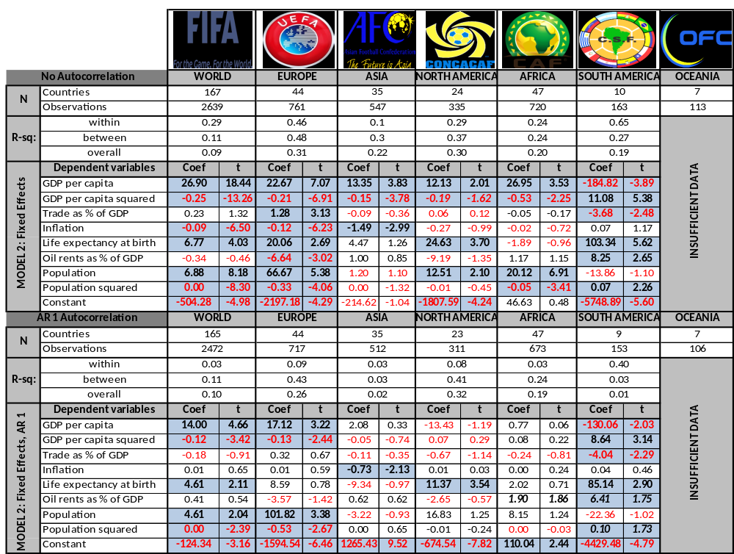
the “resource curse”, while in South America, and to a lesser degree in Africa, a relatively higher proportion of oil rents is perhaps diverted into the soccer infrastructure, thereby resulting in an estimated positive coefficient.
High inflation rates are correlated with lower FIFA points whenever statistically significant, but remain statistically significant only in Asia under the AR1 specification.
The coefficient for Life expectancy at birth is positive as expected (whenever statistically significant) for almost all confederations. Countries in South America would benefit the most from higher national health; the effect of higher life expectancy in these countries is about 20 times larger than that in Europe and about eight times larger than that in Africa (in our AR1 specification).

Equation (3)

Table 4 provides results for equation (3) using the instrumental variable technique defined in (3.1) and (3.2). All economic and resource variables are assumed exogenous on FIFA Points. CLUB is endogenous and is instrumented with UrbPop, which is expected to be positively correlated with club strength but not (directly) with FIFA Points. Note that a higher CLUB ranking is associated with a lower value (being No. 1 is better than being No. 2) and thus a negative coefficient on the variable is associated with a positive impact on the FIFA points.
We ran regressions for two sets of countries – “FIFA” and “UEFA.” While the UEFA sub-sample size was much smaller (44 countries with 722 observations) than the full sample (162 countries with 2479 observations), the regression results using the former were more consistent with our theories. Namely, for the UEFA subgroup, all of the coefficients have the expected signs, and all but one (LFB) are statistically significant at the 10% level. For the whole FIFA sample, all but one variable (LFB) have the expected signs, while only CLUB and GDP are statistically significant.
The endogenous CLUB is statistically significant at the 10% level. Its effect is about three times smaller for UEFA subgroup, compared to that of the whole sample. This is a finding supporting Foer’s (2006) position that strength of domestic leagues will have a weaker effect in Europe due to more intensive player trade. This finding also provides support for the inclusion of our “trade as a percentage of GDP” as an additional control.
GDP and Population have the expected positive-diminishing effects on soccer achievements and are statistically significant at the 5% for the UEFA subgroup. These results hold only for GDP for the FIFA sample, while Population is positive, albeit statistically insignificant.
The coefficients of Trade and Inflation have the expected signs. Trade and Inflation have a twice-larger and more precisely estimated effect on international soccer performance in UEFA countries, with statistically significance at 5 and 10 percent respectively.
Oil Rents (as a percent of GDP) are negative for both groups, statistically significant and four times larger for the UEFA region, partially confirming Foer (2004).

Table 4: Results of equation (3)
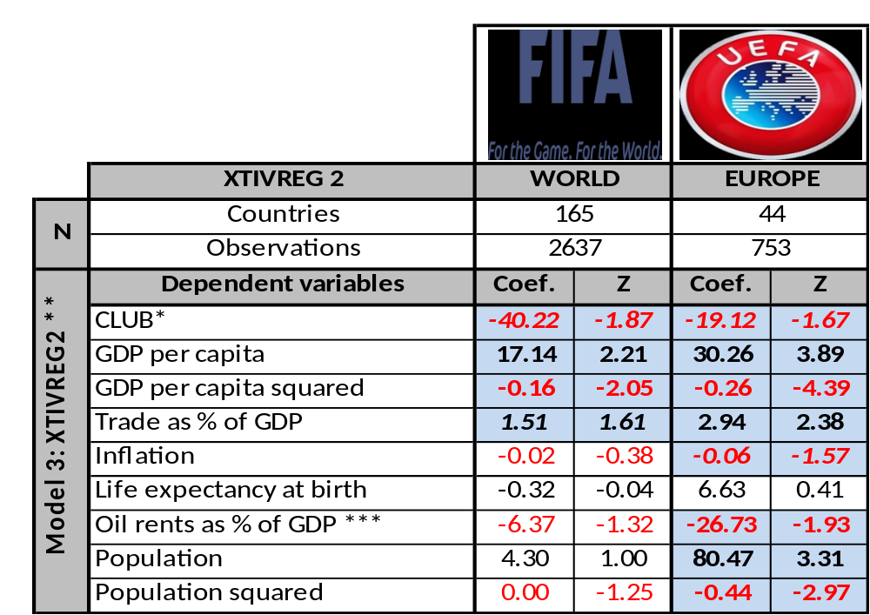

Conclusions

Statistically speaking, it helps the national soccer team to have a strong domestic league; or, at least, strong domestic club teams. Using a two-stage regression that incorporates the urban population of a country to isolating the impact of club success on national team success, we provide statistical evidence that a stronger domestic league positively affects national team performance. In one specific example, the results suggest that the U.S. Soccer team benefits from the presence of both Landon Donovan and David Beckham with the LA Galaxy.
Future work will link this research with an investigation to the extent that national teams benefit from players gaining experience in stronger leagues: more specifically, should Clint Dempsey come home?

Works Cited
Baur, Dirk and Sibylle Lehmann. 2007. Does the Mobility of Football Players Influence the Success of the National Team? Institute for International Integration Studies. IIIS Discussion Paper No. 217.
De Bosscher, Veerle, Paul De Knop, Maarten van Bottenburg, and Simon Shibli. 2006. A Conceptual Framework for Analysing Sports Policy Factors Leading to International Sporting Success. European Sport Management Quarterly.
Foer, Franklin. 2004. How Soccer Explains the World: An Unlikely Theory of Globalization. New York: HarperCollins.
Foer, Franklin. 2006. How governments nurture soccer. The New Republic posted June 19, 2006.
Hoffman, Robert, Lee Chew Ging, and Bala Ramasamy. 2002. The Socio-Economic Determinants of International Soccer Performance. Journal of Applied Economics 5(2): 253-272.
Houston, Robert G. Jr., and Wilson, Dennis P. (2002). Income, Leisure, and Proficiency: An Economic Study of Football Performance” Applied Economic Letters, 9:939-943.
Kavetsos, Georgios and Stefan Szymanksi. 2008. National Wellbeing and International Sports Events. North American Association of Sports Economists Working Paper Series, Paper No. 08-04.
Kuper, Simon and Stefan Szymanksi. 2009. Soccernomics: Why England Loses, Why Germany and Brazil Win, and Why the U.S., Japan, Australia, Turkey – and Even Iraq – Are Destined to Become Kings of the World’s Most Popular Sport. Nation Books.
Leeds, Michael A. and Eva Marikova Leeds. 2009. International Success and National Institutions. Journal of Sports Economics 10(4): 369-390.
Luiz, John and Riyas Fadal. 2010. An Economic Analysis of Sports Performance in Africa. Working Paper No. 162. Wits Business School, Witwatersrand.
Macmillan, Paul and Ian Smith. 2007. Explaining International Soccer Success and National Institutions. International Association of Sports Economists Working Paper No. 0702.
Milanovic, Branko. (2004) Globalization and Goals: Does soccer show the way? Review of International Political Economy ?(?): 829-850.
Nicholson, Michael. 2012. The Impact of Tax Regimes on International Trade Patterns. Contemporary Economic Policy, forthcoming.
Torgler, Benno. 2004. The Economics of the FIFA Football World Cup. Kyklos 57: 287-300.
Torgler, Benno. 2007. What shapes player performance in soccer? Empirical findings from a panel analysis. Applied Economics 39: 2355-2369.
Torgler, Benno. 2008. The Determinants of Women’s International Soccer Performances. International Journal of Sports Management and Marketing 3(4): 305-318.
Yamamura Eiji. 2008. Effect of Linguistic Heterogeneity on Technology Transfer: An Economic Study of FIFA Football Rankings. Mimeo, http://mpra.ub.uni-muenchen.de/10305/.

 | Table A-1: Descriptive statistics for top and bottom 15 FIFA countries in terms of average FIFA ranking (1993-2011)
 | Country |  |  | FIFA Rank |  | Club Rank |  | GDP Per Capita |  | Trade%GDP |  | Inflation |  | OR%GDP | Popmil |  | Life Exp |  | % Urban |  | Confed.
 | MAXIMUM (FIFA) |  |  | 2 |  | 3 |  | 70 |  | 372 |  | 463 |  | 62 | 1269.10 |  | 81.3 |  | 100.0
1 | Brazil |  |  | 2 |  | 3 |  | 7.8 |  | 22 |  | 232 |  | 2 | 177.2 |  | 70.5 |  | 81.9 |  | CONMEBOL
2 | Spain |  |  | 5 |  | 5 |  | 23.6 |  | 53 |  | 3 |  | 0 | 41.9 |  | 79.5 |  | 76.5 |  | UEFA
3 | Germany |  |  | 6 |  | 8 |  | 28.3 |  | 67 |  | 2 |  | 0 | 82.1 |  | 78.1 |  | 73.3 |  | UEFA
4 | France |  |  | 7 |  | 10 |  | 26.6 |  | 51 |  | 2 |  | 0 | 61.7 |  | 79.3 |  | 76.1 |  | UEFA
5 | Argentina |  |  | 7 |  | 3 |  | 10.3 |  | 31 |  | 6 |  | 3 | 37.4 |  | 74.0 |  | 90.4 |  | CONMEBOL
6 | Italy |  |  | 7 |  | 5 |  | 26.5 |  | 50 |  | 3 |  | 0 | 57.9 |  | 79.7 |  | 67.4 |  | UEFA
7 | Netherlands |  |  | 8 |  | 17 |  | 31.0 |  | 126 |  | 2 |  | 0 | 16.0 |  | 78.6 |  | 77.5 |  | UEFA
8 | England |  |  | 10 |  | 7 |  | 27.8 |  | 56 |  | 2 |  | 1 | 59.5 |  | 78.2 |  | 89.5 |  | UEFA
9 | Czech Republic |  |  | 11 |  | 48 |  | 18.0 |  | 128 |  | 5 |  | 0 | 10.3 |  | 75.3 |  | 73.9 |  | UEFA
10 | Mexico |  |  | 13 |  | 11 |  | 10.2 |  | 56 |  | 11 |  | 5 | 101.6 |  | 74.5 |  | 75.2 |  | CONCACAF
11 | Portugal |  |  | 14 |  | 16 |  | 18.8 |  | 65 |  | 3 |  | 0 | 10.3 |  | 76.8 |  | 55.3 |  | UEFA
12 | Chile |  |  | 15 |  | 11 |  | 15.8 |  | 71 |  | 1 |  | 0 | 17.1 |  | 78.9 |  | 89.0 |  | CONMEBOL
13 | Denmark |  |  | 17 |  | 34 |  | 30.3 |  | 85 |  | 2 |  | 1 | 5.4 |  | 76.9 |  | 85.6 |  | UEFA
14 | USA |  |  | 19 |  | 38 |  | 36.9 |  | 25 |  | 2 |  | 0 | 285.5 |  | 76.9 |  | 79.5 |  | CONCACAF
15 | Russia |  |  | 19 |  | 19 |  | 10.3 |  | 56 |  | 95 |  | 13 | 145.1 |  | 66.2 |  | 73.2 |  | UEFA
 | MEAN (FIFA) |  |  | 92 |  | 63 |  | 11 |  | 88 |  | 21 |  | 5 | 36.57 |  | 67.6 |  | 54.7
186 | Seychelles |  |  | 168 |  | 80 |  | 18.0 |  | 198 |  | 9 |  | 0 | 0.1 |  | 72.4 |  | 52.9 |  | CAF
187 | Guyana |  |  | 171 |  | 84 |  | 2.2 |  | 204 |  | 6 |  | 0 | 0.7 |  | 64.6 |  | 28.6 |  | CONCACAF
188 | Philippines |  |  | 174 |  | 83 |  | 2.7 |  | 90 |  | 6 |  | 0 | 79.8 |  | 67.0 |  | 59.6 |  | AFC
189 | Samoa |  |  | 175 |  | 83 |  | 3.4 |  | 92 |  | 5 |  | 0 | 0.2 |  | 70.3 |  | 22.3 |  | OFC
190 | Cambodia |  |  | 175 |  | 83 |  | 1.3 |  | 111 |  | 6 |  | 0 | 12.8 |  | 58.9 |  | 18.4 |  | AFC
191 | Papua New Guinea |  |  | 176 |  | 83 |  | 1.8 |  | 122 |  | 9 |  | 13 | 5.6 |  | 59.4 |  | 13.1 |  | OFC
192 | Tonga |  |  | 179 |  | 83 |  | 3.8 |  | 71 |  | 6 |  | 0 | 0.1 |  | 71.2 |  | 23.8 |  | OFC
193 | Belize |  |  | 181 |  | 84 |  | 5.3 |  | 116 |  | 2 |  | 0 | 0.3 |  | 74.0 |  | 49.0 |  | CONCACAF
194 | Macau |  |  | 181 |  | 84 |  | 31.5 |  | 155 |  | 3 |  | 0 | 0.5 |  | 78.8 |  | 100.0 |  | AFC
195 | Central African Rep. |  |  | 182 |  | 84 |  | 0.7 |  | 38 |  | 5 |  | 0 | 3.8 |  | 45.0 |  | 37.8 |  | CAF
196 | Bahamas |  |  | 182 |  | 82 |  | 30.3 |  | 90 |  | 2 |  | 0 | 0.3 |  | 73.3 |  | 83.0 |  | CONCACAF
197 | Brunei Darussalam |  |  | 182 |  | 80 |  | 44.8 |  | 106 |  | 1 |  | 26 | 0.3 |  | 76.2 |  | 71.3 |  | AFC
198 | Mongolia |  |  | 186 |  | 82 |  | 2.8 |  | 117 |  | 9 |  | 1 | 2.5 |  | 65.3 |  | 56.9 |  | AFC
199 | Afghanistan |  |  | 189 |  | 81 |  | 1.0 |  | 79 |  | 9 |  | 0 | 32.1 |  | 47.4 |  | 23.9 |  | AFC
200 | Djibouti |  |  | 194 |  | 80 |  | 1.8 |  | 96 |  | 3 |  | 0 | 0.8 |  | 55.2 |  | 85.5 |  | CAF
 | MINIMUM (FIFA) |  |  | 194 |  | 87 |  | 0.3 |  | 1 |  | -0.3 |  | 0 | 0.04 |  | 44.1 |  | 8.2
 |  | Table A-2: Descriptive statistics for 15 top and bottom UEFA countries in terms of average FIFA ranking over 1993-2011
 |  | Country | FIFA Rank |  | Club Rank |  | GDP Per Capita |  | Trade % GDP |  | Inflation |  | Oil % GDP |  |  | Population |  | Life Expectancy |  | % Urban
 |  | MAXIMUM(UEFA) | 5 |  | 5 |  | 59.3 |  | 258 |  | 349 |  | 38 |  |  | 145.1 |  | 80.2 |  | 97.1
1 |  | Spain | 5 |  | 5 |  | 23.6 |  | 53 |  | 3 |  | 0 |  |  | 41.9 |  | 79.5 |  | 76.5
2 |  | Germany | 6 |  | 8 |  | 28.3 |  | 67 |  | 2 |  | 0 |  |  | 82.1 |  | 78.1 |  | 73.3
3 |  | France | 7 |  | 10 |  | 26.6 |  | 51 |  | 2 |  | 0 |  |  | 61.7 |  | 79.3 |  | 76.1
4 |  | Italy | 7 |  | 5 |  | 26.5 |  | 50 |  | 3 |  | 0 |  |  | 57.9 |  | 79.7 |  | 67.4
5 |  | Netherlands | 8 |  | 17 |  | 31.0 |  | 126 |  | 2 |  | 0 |  |  | 16.0 |  | 78.6 |  | 77.5
6 |  | England | 10 |  | 7 |  | 27.8 |  | 56 |  | 2 |  | 1 |  |  | 59.5 |  | 78.2 |  | 89.5
7 |  | Czech Republic | 11 |  | 48 |  | 18.0 |  | 128 |  | 5 |  | 0 |  |  | 10.3 |  | 75.3 |  | 73.9
8 |  | Portugal | 14 |  | 16 |  | 18.8 |  | 65 |  | 3 |  | 0 |  |  | 10.3 |  | 76.8 |  | 55.3
9 |  | Denmark | 17 |  | 34 |  | 30.3 |  | 85 |  | 2 |  | 1 |  |  | 5.4 |  | 76.9 |  | 85.6
10 |  | Russia | 19 |  | 19 |  | 10.3 |  | 56 |  | 95 |  | 13 |  |  | 145.1 |  | 66.2 |  | 73.2
11 |  | Sweden | 19 |  | 47 |  | 29.4 |  | 83 |  | 1 |  | 0 |  |  | 9.0 |  | 79.9 |  | 84.1
12 |  | Romania | 20 |  | 39 |  | 8.3 |  | 67 |  | 50 |  | 2 |  |  | 22.1 |  | 71.1 |  | 53.9
13 |  | Norway | 24 |  | 40 |  | 38.9 |  | 72 |  | 2 |  | 11 |  |  | 4.5 |  | 79.1 |  | 76.0
14 |  | Croatia | 26 |  | 84 |  | 13.0 |  | 87 |  | 92 |  | 1 |  |  | 4.5 |  | 74.0 |  | 56.0
15 |  | Turkey | 28 |  | 28 |  | 9.7 |  | 47 |  | 46 |  | 0 |  |  | 64.9 |  | 69.9 |  | 65.4
 |  | MEAN (UEFA) | 54 |  | 52 |  | 18.9 |  | 94 |  | 37 |  | 2 |  |  | 21.0 |  | 74.8 |  | 68.6
34 |  | Latvia | 74 |  | 68 |  | 10.4 |  | 100 |  | 14 |  | 0 |  |  | 2.4 |  | 70.2 |  | 68.3
35 |  | Wales | 75 |  | 83 |  | 27.8 |  | 56 |  | 2 |  | 1 |  |  | 59.5 |  | 78.2 |  | 89.5
36 |  | FYR Macedonia | 78 |  | 78 |  | 7.1 |  | 99 |  | 10 |  | 0 |  |  | 2.0 |  | 73.3 |  | 63.9
37 |  | Cyprus | 79 |  | 36 |  | 21.8 |  | 100 |  | 3 |  | 0 |  |  | 1.0 |  | 78.1 |  | 68.9
38 |  | Georgia | 85 |  | 71 |  | 3.1 |  | 72 |  | 19 |  | 0 |  |  | 4.4 |  | 72.0 |  | 52.9
39 |  | Belarus | 86 |  | 71 |  | 7.1 |  | 128 |  | 277 |  | 2 |  |  | 9.9 |  | 69.0 |  | 70.7
40 |  | Albania | 91 |  | 82 |  | 5.1 |  | 64 |  | 12 |  | 2 |  |  | 3.1 |  | 74.5 |  | 42.8
41 |  | Estonia | 94 |  | 83 |  | 12.8 |  | 150 |  | 14 |  | 0 |  |  | 1.4 |  | 71.0 |  | 69.6
42 |  | Moldova | 101 |  | 69 |  | 2.1 |  | 128 |  | 15 |  | 0 |  |  | 3.6 |  | 67.5 |  | 43.7
43 |  | Armenia | 104 |  | 82 |  | 3.2 |  | 74 |  | 277 |  | 0 |  |  | 3.1 |  | 71.5 |  | 64.9
44 |  | Azerbaijan | 118 |  | 77 |  | 4.2 |  | 87 |  | 127 |  | 38 |  |  | 8.2 |  | 67.6 |  | 51.7
45 |  | Malta | 123 |  | 81 |  | 19.2 |  | 171 |  | 3 |  | 0 |  |  | 0.4 |  | 78.3 |  | 92.7
46 |  | Kazakhstan | 130 |  | 75 |  | 7.0 |  | 86 |  | 131 |  | 21 |  |  | 15.4 |  | 65.9 |  | 56.8
47 |  | Luxembourg | 137 |  | 82 |  | 59.3 |  | 258 |  | 2 |  | 0 |  |  | 0.4 |  | 78.2 |  | 82.9
48 |  | Tajikistan | 145 |  | 70 |  | 1.6 |  | 104 |  | 14 |  | 0 |  |  | 6.5 |  | 65.7 |  | 26.5
 |  | MINIMUM (UEFA) | 145 |  | 84 |  | 1.6 |  | 46 |  | 1 |  | 0 |  |  | 0.4 |  | 65.7 |  | 26.4

∇ Paper prepared for the 2012 Western Economic Association International conference in San Francisco, CA.
* Corresponding author: sahakyan@wisc.edu.
** Office of Economic Growth, USAID/Liberia, 502 Benson Street, Monrovia, Liberia, mnicholson@usaid.gov. The views expressed in here are those of the authors and do not reflect the opinions of the US Agency for International Development.
*** Contact: Dave.Kritzberg@gmail.com.
Throughout this paper, we will use the terms “football” and “soccer” interchangeably.
In a very telling example, the best player of his generation and three-time reigning FIFA/Balon d’Or Player of the Year (2009, 2010, 2011) Lionel Messi left his home-town club in Argentina to play for FC Barcelona, because the Argentine club was unable to afford his growth hormone deficiency treatment. Foer (2004) quotes the two-time Balon d’Or winner Ronaldo (Brazil) saying “I will not go back to play in Brazil for any offer.”
In the 2011-2012 UEFA Champions League, the most prestigious club competition in Europe (and arguably in the world), four clubs from Spain participated. Out of these four, defending champions FC Barcelona and Real Madrid made it to the semi-finals, and only failed penalty kicks prevented an all-Spanish final. There was, however, another all-Spanish club final, between Atletico Madrid and Athletic Bilbao, in this year’s Europa League, the second most important European Club competition.
¹The number of points that can actually be won in a match depends on the following factors: Was the match won, or did it end in a draw? (M) How important was the match (friendly match to FIFA World Cup)? (I) How strong was the opponent in terms of its ranking position and the confederation to which it belongs? (T and C) These factors are brought together in the following formula to ascertain the total number of points (P). P = M x I x T x C x 100; Source: www.fifa.com
The index is created by summing up points and creating an annual ranking of all clubs by country, using only the points accumulated in international club competitions. Source: http://www.clubworldrankings.com/. We are thankful to Mark de Vries of clubworldrankings.com, for providing the club soccer data.
As has recent history. Foer closes the article with the “iron law that overrides all the others”: the political regime most destined for success is whichever regimes holds power in Brasilia. Two World Cups later, Brazil has failed to even make the semifinals and Lula is out of power.
Another finding is that temperature and population are insignificant in all of the specifications.
data.worldbank.org/data-catalog/world-development-indicators
www.fifa.com; www.clubworldrankings.com
Among others, Nicholson (2012) argues that the trade literature does itself a disservice with such a characterization. Data on exports plus imports relative to GDP does not necessarily reflect the “openness” of a country, given that countries like Canada and the United States maintain quite open trading regimes but do not have a high percentage of GDP in international trade due to the size of their domestic economies. For present purposes, however, this measure may accurately capture a proxy of international exposure. Belgium and Netherlands, in the heart of Europe, are the standard bearers for trade as a percentage of GDP, and at the geo-political center of professional club soccer.
Kuper and Szymanski (2009), “Soccernomics,“ Chapter 7, “The Suburban Newsagents: City Sizes and Soccer Prizes”
Time and country indices are dropped for ease of notation.
And, perhaps, England, although their national team has not reached the finals of a major international soccer tournament since 1966.
See supra note 2.
For the econometric specification, we are not concerned about the magnitude of his indirect contributions so much as whether they exist at all.
Black is positive, red is negative, bold is statistically significant at 5%, bold-italic is statistically significant at 10%. Blue shade indicates statistical significance at 10% or higher. All statistical estimation in this study is performed using STATA 12.0
These country comparisons are in current international dollars (2010).
Black is positive, red is negative, bold is statistically significant at 5%, bold-italic is statistically significant at 10%. Shading indicates statistical significance (10% and lower) . Oceania was excluded due to insufficient number of observations.
Black is positive, red is negative, bold is statistically significant at 5%, bold-italic is statistically significant at 10%. Shading indicates statistical significance at 10% or less. * Endogenous with FPS; instrumented by Urban population in the first stage, statistically significant at 5%. ** Uses heteroskedasticity and autocorrelation - robust SE's. Does not estimate a constant. *** Uses modified Oil Rents data refined from its original WDI version from IMF and other sources.

